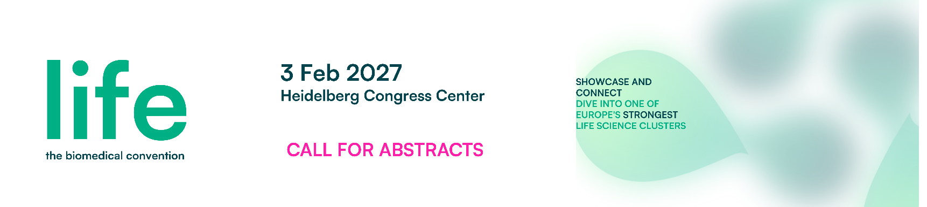
The Concept:
The “Young Scientists Pitch Competition” is a dedicated session for Master- or PhD-Students and young Postdocs at life – the biomedical convention (formerly BioRN Annual Conference). Research abstracts should be in line with the conference topic: “AI in Health” for life science application. Selected research abstracts have the possibility to pitch during the conference in front of an audience from industry and academia experts and compete for a monetary prize.
The Process*:
- Call for Research Abstract – Submit your research abstract to Nicole Hecht (nh@biorn.org) by using the template in this document and highlighting new discoveries or innovative approaches in the field.
- Evaluation – A jury from experts in the field will evaluate all received abstracts using a score card. Following criteria will be considered: Scientific quality / high standard of research; Originality/ Innovativeness of Idea/ novelty; Relevance and Impact; Advancement of field.
- Selection - The best 5 research abstracts will be invited to pitch their research at “life - the biomedical convention”.
- Pitch Competition – the pitch competition takes place during a dedicated session of “life - the biomedical convention”. Each author will have 5-10’-time to impress the audience with his/her innovative research concept.
- Winner Announcement and Prize – The onsite conference jury will select the best oral presentation and assign the 1,000 EUR prize.
The Benefits:
- Possibility to reach out to top-experts in the field
- Visibility within a scientific audience of industry and academia players
- Inclusion in the conference website and abstract booklet
Monetary prize of 1,000 EUR
The timeline:
Deadline Call for Abstracts 15 November 2026 (to nh@biorn.org)
Selected abstract announcement before 15 December 2026
Pitch competition at life – the biomedical 3 February 2027
convention & winners announcement

* Subject to change
About life – the biomedical convention:
Since 2009, each year life – the biomedical convention (formerly BioRN Annual Conference) has been a valuable source of top information, lively discussions and networking opportunities with international experts from different fields of the life sciences. Life – the biomedical convention attracts up to 500 delegates from around 200 companies and institutions, facilitating face to face meetings, offering exhibition space for 30+ showcasing companies and organizations.

AI in Health
AI in Health and Biomedicine is transforming every stage of biomedical innovation. From AI-driven drug discovery, computational protein design, and digital pathology to precision medicine and data-driven diagnostics, artificial intelligence is accelerating research while reshaping clinical practice. As AI becomes increasingly integrated into healthcare, it also raises important questions around regulation, data integration, and the evolving role of scientists, clinicians, and decision-makers in the biomedical ecosystem.

Dive into the topic and look forward to more speakers we are going to announce soon at our website.

Application Template
Title
Authors and Affiliations (please underline the presenting author)
Research Group(s) (including link to webpage)
Abstract (max. 2000 characters including spaces)
Max 3 relevant references from literature
- …
- …
- …

